### **[Print Settings for PETG: eSUN Solid Black Filament](http://forum.makergear.com/viewtopic.php?f=11&t=2593#p15261)**

Several people have recently asked why there isn’t a single list of settings and properties for printing various filaments – the short answer is – because different things can work based on different printer setups, and most of the people here have made at least one modification to their printer. For future newbies to PETG – these are my personal notes on printing this filament, some from my own tests, but mostly from the “Wisdom of the Boys of the Forum” – I’m just recording it in one place. When I’m done, they can correct whatever I’ve gotten wrong, or add their recommendations, and we’ll have it for reference.

Please remember – these are just a starting point – you can expect to have to fiddle with the settings to fine tune them to suit your setup. Keep in mind that the nozzle style you have and the method that you use to stick the print to the plate can change the settings you want to use. Even the version of S3D that you are using introduces changes. Basically, you will always get the best results through personal trial and error.

Standard disclaimer aside.....At the end of my notes, I’ll post the settings that work for me, for both the V3B and V4 nozzles, in case someone else wants to use them as a starting point. It really does print beautifully once you have it set up correctly.

(And I’m moving these into a separate thread since the original eSun PETG thread has gotten to be about 40 pages long now. Oooof!)

**General Notes:**

1. PETG is very strong, somewhat flexible and can be used at higher temps than PLA. It makes a good choice for printing replacement parts for the M2 at high (60%+) infill. It has no odor when printing, and does not need an enclosure. It does not warp or crack like ABS. Natural PET is safe for food contact (water bottles), but not necessarily the colored PETG.

It’s a bit fiddly to get set up, but once you do, it prints like a dream.

2. Single most important thing with this filament is the calibration – it needs enough room to lay down the thread without brushing the previous layer. Any brushing at all of the prior layer and you get stringy threads that build up on the nozzle and then can dump in a glob later in your print, leave little zits all over the place, or give the print a rough, matte, almost glittery surface, especially on curved areas. The filament almost likes to “air print” by just a tiny bit. If you are getting a lot of buildup on the nozzle, move the first layer away from the nozzle by adding +0.02 mm increments to the Z-Offset in the G-Code section of S3D, until it quits. You do not smash this filament down to make it stick.

3. It’s also a very sticky/oozy filament, so you have to use retraction to suck it back into the nozzle, to prevent blob build up at the layer starting points. Wiping is a very good idea with this filament, about 5.0 mm or so, to prevent a ridge buildup at the starting points. (Coasting can also work, but it can leave gaps or thin points in the wall, so I personally prefer wiping.)

4. Under-extrude a little bit. It gives a much nicer surface. Whatever the Extrusion Multiplier is that you determined during the calibration, reduce it by -0.01. (So if your calibrated extrusion multiplier is 0.85, take it down to 0.84) PETG cannot handle over-extrusion without making a mess.

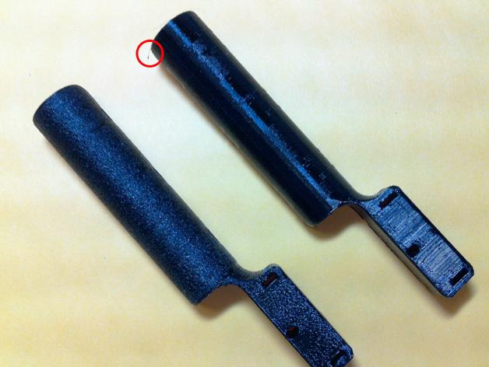

*Normal extrusion on left, Slightly under-extruded on the right. Both prints are fully functional, but the left version is literally covered with thousands of tiny threads that wrapped around the print making the surface rough and glittery. The one string on the under-extruded print is the one that was left at the very end, when the bed moved down.*

PETG_underextrusion_comparison.jpg (277.11 KiB) Viewed 317131 times

5. Print **slowly**. The slower you go, the better PETG likes it. Speeds under 60mm/sec. are recommended – I use about 53 mm/sec. and slow the first layer down to 40% in addition to that. It does not add that much time to the print. And another tip that i just remembered.....When you purge PETG, be very careful to not purge too much at one time (Sticking with 10 mm extruded at a time, several times in a row, is a heck of a lot better than shooting a 100 mm purge through at once.) PETG needs time to melt in the nozzle - it is possible if you purge PETG too quickly through a V4 nozzle, to push the blasted nozzle right out of the seat! Then you have to reset your Z-stop, and rework all your profiles.

6. Don’t get too hung up on using an extrusion multiplier that falls into a specific range – I’ve had the calibrated extrusion multipliers run from 0.78 to 0.88 on different spools of PETG. That bothered me (a lot), until I had a print that suddenly developed fur, on a spool that had been printing fine for a month. Turned out the filament diameter had gradually swung from an average of 1.73 mm at the start up to an average of 1.78 mm at about an inch into the roll, and recalibrating fixed it. The point is – there are going to be some swings in the filament diameter, and possibly the density. Sometimes, for important prints, I re-check the diameter where it goes into the feeder tube. If it’s way off, I recalibrate, otherwise I just let it go, and change the filament diameter in the Other settings. (It’s another reason to under-extrude a bit.)

7. The temperature that you use changes based on which nozzle you are using, the V4 tends to run a little hotter. It also changes depending on whether you run your fan for cooling or not.

The layers tend to bond together better (laminate) with no fan. But the surface finish is nicer if you do run the bed fan on full after the first layer, and if you need to do any bridging at all, you want that fan turned on full.

The compromise, (which works pretty well), is to use the bed fan, but increase both the nozzle temp and the bed temp by a few degrees to help with layer bonding and keep the print stuck to the plate.

If you’re printing for strength…cut the fan. The bond is a lot stronger. You will probably need to ream out the hole a bit after bridging.

(And, in either case, use no external fans.)

8. You will want to use an infill of at least 35-40%, particularly on large prints, **or** use at least 3 or more top layers. This filament is so saggy that it takes several surface layers to fill in the depressions that form over skimpy infill.

9. Certain parameters listed in the suggested settings also change, depending on which version of Simplify3D you are using. The amount of overlap on infill and infill extrusion width had to be adjusted a bit between version 2.2 and 3.01, based on how the different versions of S3D handle it. (Just something to keep in mind, I list both in the suggested settings. Be sure to pick the right one.)

10. The settings shown are for eSun Black Opaque PETG. Other PETG filaments are going to have slightly different settings. These are a good starting point for any kind of PETG, but you will need to make adjustments to them if you are printing something else. The translucent PETGs print very differently. (Frankly they’re a lot easier to dial in, and seem a bit less sticky.)

11. Bridging: The opaque PETG is damned hard to bridge. It sags, and the strands do not catch properly at the edges, causing build-up on the nozzle. They also draw out at higher bridging speeds, thinning, and providing little support for subsequent layers.

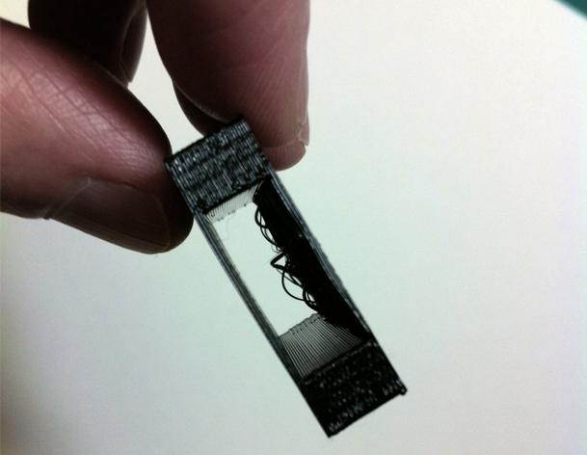

*Bridging with no adjustments, full fan.*

PETG_bridging.jpg (184.6 KiB) Viewed 317131 times

I’ve run several thousand bridging tests over the last few days, (slight exaggeration), and the best I can come up with is to increase the extrusion while bridging (to keep the thread from being pulled so thin that it breaks while it bridges) and moderately increasing the bridging speed so that it gets across the gap before it breaks. If you are running S3D version 3.01, you can also inflate the bridging distance by 1.0 mm, to make sure the edges catch. (Do not go over 1.0 mm though…too much, and it stretches and breaks again.)

The direction of bridging makes a big difference in the quality, with bridging along the x axis (from left to right) being best, and bridging along the y axis (front to back) being worst. Angled bridging falls in between.

Increasing the bridging extrusion rate and the speed helps cut down significantly on the sagging, as does extending the bridge by no more than a millimeter over the edge.

And one final note, and this one is a doozy – if you take the standard fan guard off of the bed fan before you print, the bridge gets a lot more cooling flow at the critical moment, and it cuts way down on the sagging factor. You do have to be extra careful not to drop anything into your fan if you take the guard off (those modifications, you know) but it’s up to you. The difference is very visible.

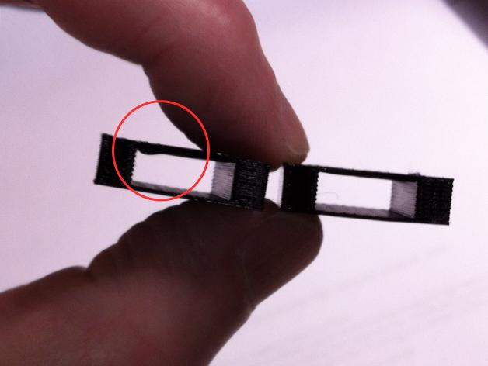

*With fan guard installed on left, fan guard removed on the right. Significantly less sagging during bridging.*

Fanguard.jpg (168.09 KiB) Viewed 317131 times

Bottom line: If you do have to use PETG to bridge, make sure you have multiple layers on top, and plan to ream out the saggy interior if you run it without fan.

12. Some final tips:

Q-tips are great for reaching in and carefully swiping off a build-up that you see collecting on your nozzle, when you are hours into a print and finally notice it. It’s also great for cleaning up the nozzle after the print finishes, while the nozzle is still hot. A long toothpick will also work.

Plan on catching the purge with your tweezers at the side of the bed when you start a print. It just prevents the possibility of early blobs, although the wipe usually does a fairly good job.

It is absolutely critical that you get the nozzle far enough away from prior threads that have been laid down - if your print wrecks due to buildup – move the bed farther away for the first layer.

And if you plan to switch back and forth between printing PETG and PLA using the same nozzle, you need to pick up some cleaning filament to run through the nozzle. The higher melting temp for PETG will cook leftover PLA right onto your nozzle, narrowing the diameter of the hole and eventually resulting in a clog.

The Settings:

**PETG: eSUN Solid Black**

**1. Calibrations:** Do this first, using the instructions here:

[viewtopic.php?f=3&t=3124](http://forum.makergear.com/viewtopic.php?f=3&t=3124)

*(skip this step if you have a Rev.E machine. Sold after 3/1/16.)*

**2. Extruder:**

Overview:

Nozzle Diameter: 0.35 mm

Extrusion Multiplier: Calibration result - 0.01; (0.89-0.01=0.88) for my printer

Extrusion Width: 0.45 mm Manual

Ooze Control:

Retraction: checked-yes

Retraction Distance: 1.20 mm

Extra Restart Distance: 0 mm

Retraction vertical lift: 0.60 mm; (generally not needed, PETG does not tend to warp up, unless you are getting a lot of strings)

Retraction Speed: 2400 mm/min

Coasting: none; (tried it, but it was thinning out the threads too much at the start)

Wipe Nozzle: checked-yes

Wipe Distance: 5.00 mm

**3. Additions:**

A skirt usually gets rid of any last globs after the purge.

Skirt Layers: 1

Skirt Offset from Part: 4.0 mm

Skirt Outlines: 3

**4. Layer:**

Primary Layer Height: 0.25 mm; (PETG likes a taller layer, and it speeds things up - still gives very smooth finish)

Top Solid Layers: 4-5; (especially for infill under 40%. You can get by with fewer top layers at infills of 40%+)

Bottom Solid Layers: 4-5, if bridging; (can get by with fewer if not bridging)

Outline/Perimeter Shells: 1

Outline Direction: Inside-Out if you have overhangs, otherwise Outside-in

First layer height: 97%

First Layer Width: 100%

First Layer Speed: 40%

Start Points: Optimize start points for fastest printing speed; (personal preference, if you have it dialed in correctly, there will be no globs at the start of your layers)

**5. Infill:**

Internal Fill Pattern: Fast Honeycomb for S3D version 3.0+; Rectilinear for S3D version 2.2

External Fill Pattern: Rectilinear for most, Concentric for domes

Interior Fill Percentage: varies

Outline Overlap: 10% for S3D version 3.0+; 15% for S3D version 2.2

Infill extrusion width: 103% for S3D version 3.0+; 130% for S3D version 2.2; (not a typo, they are different)

Minimum infill length: 2 mm

Print Sparse Infill Every: 1 layer

Include solid diaphragm: no

Infill Angle Offsets: Fast Honeycomb: 0; Rectilinear: 45,-45

**6. Support:**

Generate Support Material: checked if needed

Support infill percentage: 30%

No Dense Support

Horizontal Offset: 0.3 mm

Upper Vertical Separation Layers: 1

Lower Vertical Separation Layers: 0

**7. Temperatures:**

Extruder:

Layer 1 temp: 250°C V3B nozzle; 247°C V4 nozzle

Layer 2 temp: 242-247°C V3B nozzle; 240-242°C V4 nozzle

Bed: Hairspray or gluestick on Kapton tape or glass

Bed temp: 85°C no fan; 87°C with fan

Bed: Zebra Plate

Bed Temp: 87°C, with or without fan; (A Zebra plate reduces the temp to the part from the heated bed, but a lower surface temp is needed to stick the print thoroughly to the plate. Once it cools, the print lifts off very easily.)

(Addendum: If you remove your fan guards, you might need to up the temp by a few degrees. It really does cool things off.)

Bed: PEI on glass

Bed temp: 70°C

**8. Cooling**

Layer 1: 0%

Layer 2: 0%; If you want strength in your layer bonds, use zero bed fan, extruder temp: 242°, bed temp: 85°

Layer 2: 100%; If you want a nicer surface finish, or need bridging in the part, use 100% bed fan on layer 2, but increase the extruder temp to 247°, and the bed temp to 87°

(Addendum: If you remove your fan guards, you might need to up the temps by a few degrees. It really does cool things off.)

**9. G-code**

**Global Z-Offset**: variable;

This number needs to be determined through your calibration. Positive numbers here move the bed farther away from the nozzle, giving more space to the extruded thread. Negative numbers here move the bed closer to the nozzle, squishing the thread. Make small adjustments to this value until the thread is no longer squished. *(Does not apply to Rev.E machines.)*

**10. Scripts**

Starting Script:

I added Jin's deceleration code in the Starting Script for this filament....it slows down the nozzle as it approaches an edge (cuts down on ringing around holes....i think)

*M201 X1000 Y1000 ; slows acceleration*

Ending Script:

I added a couple of things into this one to cut off both fans when a print is done and drop the bed down to just above the return spring on my printer.

(Very handy - these codes are in all my profiles.)

*M104 S0 ; turn off extruder*

*M140 S0 ; turn off bed*

*G91 ; relative mode*

*G1 Z10 ; lift 10mm*

*G90 ; absolute mode*

*G1 Z195 ; drop Z axis to just above spring*

*G28 X0 ; home X axis*

*M84 ; disable motors*

*M106 S0 ; stop bed fan*

*M108 S0 ; stop extruder and electronics fans*

**11. Other**

Speeds:

Default printing speed: 3200 mm/min

Outline underspeed: 50%

Solid infill underspeed: 75%

Support structure underspeed: 75%

X/Y axis movement speed: 12000 mm/min

Z axis movement speed: 1200 mm/min

Horizontal Size compensation: 0 mm

Filament Properties:

Filament diameter: variable This has to be measured for each spool, and sometimes before a print, too. (1.75 mm avg. currently on my spool)

Filament Price: Calulates the cost of the print if you put your actual cost in

Filament density: 1.25 grams/cm3 (the default)

Bridging:

Unsupported area threshold: 10.0 sq. mm (This stuff sags, the calcs & bridging speed only kick in above this size, so i set it small.)

Extra Inflation Distance: 1.0 mm (Only available in S3D version 3.0+)

Bridging extrusion multiplier: 140%

Bridging speed multiplier: 125%

**12. Advanced**

Slicing Behavior: Heal non-manifold segments

Thin Wall Behavior: Allow Gap Fill when necessary: checked-yes

Allowed perimeter overlap: 0%

Ooze Control Behavior:

Only retract when crossing open spaces: unchecked-no

Force retraction between layers: checked -yes

Minimum travel for retraction: unchecked

Perform retraction during wipe movement: checked - yes

Only wipe extruder for outermost perimeters: checked- yes

Movement Behavior:

Avoid crossing outline for travel movements: unchecked - no

Okay, that's it. If I left a setting off the list, it was just the default, and should be left at what S3D has it set to. (Wow, my eyes are tired now. Let's not do this again for a while. :shock: )